Macroeconomics II: Homework Assignment 3

2. Replicate Figure 4 of Leeper, Sims, and Zha (1994). You can use industrial production index, instead of monthly GDP.

Data on all the variables was obtained from the Federal Reserve Economic Data (FRED), Economic Research Division of the Federal Reserve Bank of St. Louis. The data set covers the period of July 1959 to March 1996, the frequency is monthly, and all of the variables, other than the federal funds rate, were measured in logs. Below is a brief description of the data set for each variable. Also, I provided an explanation to the VAR procedure I implemented.

Y (Industrial Production Index):
Link: http://research.stlouisfed.org/fred2/series/INDPRO/downloaddata?cid=3
Title: Industrial Production Index
Series ID: INDPRO
Source: Board of Governors of the Federal Reserve System
Seasonally Adjusted
Unites: Natural Log of Index 2007 = 100

CPI (Consumer Price Index):
Link: http://research.stlouisfed.org/fred2/series/CPIAUCSL/downloaddata?cid=9
Title: Consumer Price Index for All Urban Consumers: All Items
Series ID: CPIAUCSL
Source: U.S. department of Labor: Bureau of Labor Statistics
Seasonally Adjusted
Units: Natural Log of Index 1982-84 = 100

M1 (M1 Money Stock):
Link: http://research.st.louisfed.org/fred2/series/M1SL/downloaddata?cid=25
Title: M1 Money Stock
Series ID: M1SL
Source: Board of Governors of the Federal Reserve System
Seasonally Adjusted
Units: Natural Log of Billions of Dollars

RF (Effective Federal Funds Rate):
Link: http://research.stlouisfed.org/fred2/series/FEDFUNDS/downloaddata?cid=118
Title: Effective Federal Funds Rate
Series ID: FEDFUNDS
Source: Board of Governors of the Federal Reserve System
Units: Percent

VAR Procedure
I imported the data into EViews, and then I ran VAR. The endogenous variables were CPI, M1, Y, and RF, while the exogenous variable was C. The lag interval was six, the periods were 48, and I used an adjusted Cholesky decomposition.
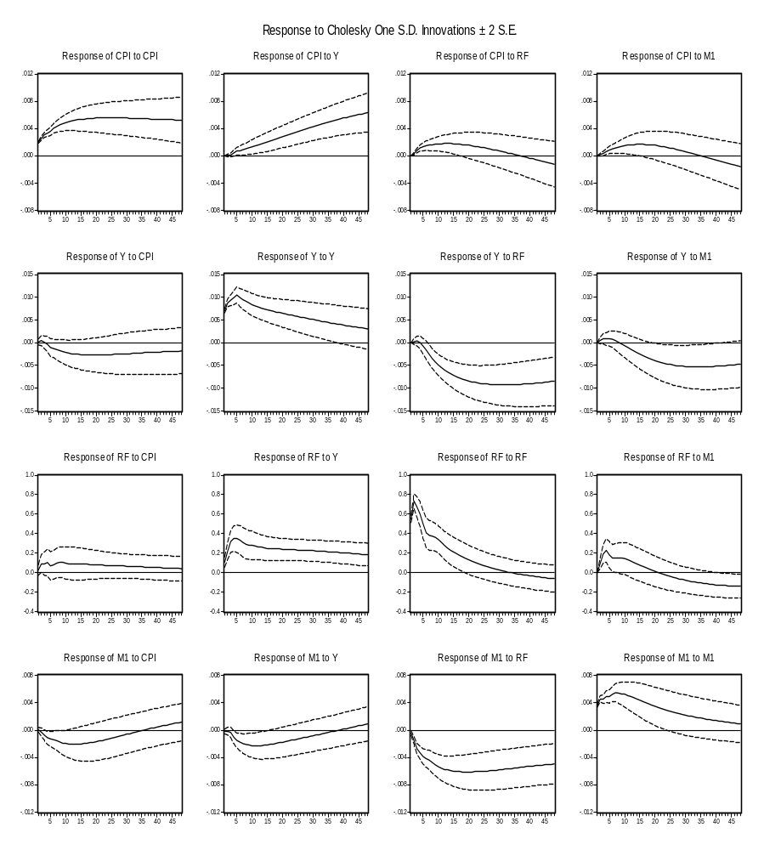

3. Discuss your results on the following points. What do they reveal about the monetary policy effects? What are the possible issues of your interpretation of the results?

Response of CPI to M1: The percentage deviation of CPI from its mean is positive for approximately 35 months and after that it becomes negative. The Issue with this response of CPI is that we would expect inflation to occur in response to monetary expansion and inflationary trend should disappear as monetary aggregates tends to their mean value, but this does not happen. Instead we have deflation 35 months after the monetary shock.

Response of Y to M1: Output has positive deviation from mean for a little less than ten months, and then the deviation becomes negative. After about 30 months, output levels off at -0.5%. The issue with this response is that we have monetary expansion for almost 10 months and we would expect output to increase during this period, but the positive deviation of output is very small and then output is lower than its mean for the rest of the period, which does not comply with the effect of expansionary monetary policy on output.

Response of RF to M1: From Figure I, it can be seen that interest rates are higher than average value for almost 20 months. For the remaining time periods, it is lower than the average value. The liquidity effect states that interest rates should decrease in presence of expansionary monetary shock. Until 20 months after the monetary policy shock, the response of interest rates contradict the liquidity effect.

